AP English Language and Composition Summer Reading Assignment
Mr. Havlicek: dhavlicek@myjacs.org, www.havlicek.weebly.com,
This summer’s reading assignment includes David and Goliath: Underdogs, Misfits, and the Art of Battling Giants by Malcolm Gladwell (ALL STUDENTS WILL READ THIS), and a choice of one of the following works of non-fiction: Black Flags: The Rise of ISIS by Joby Warrick; The Price of Admission: How America’s Ruling Class Buys Its Way into Elite Colleges—and Who Gets Left Outside the Gates by Daniel Golden; or Talent is Overrated by Geoff Colvin; OR a work of fiction from these two choices: In Cold Blood by Truman Capote; and The Goldfinch by Donna Tartt.
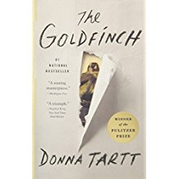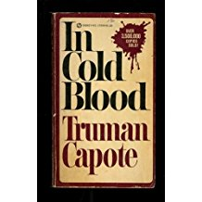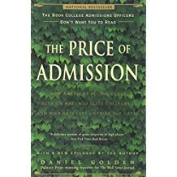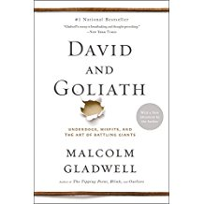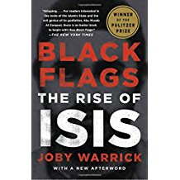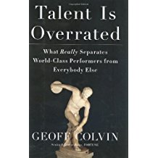
Save your work! You will be submitting these assignments to me when you get to school this fall. Also, make sure you write in 12 Point Font, Times New Roman. Include page numbers, double-spacing, and MLA citations (where appropriate).
- Part I: (Due via email to dhavlicek@myjacs.org by 11:59pm on Wednesday, July 18, 2018): Read David and Goliath: Underdogs, Misfits, and the Art of Battling Giants by Malcolm Gladwell (ISBN-13: 978-0316204378) and complete a Reader Response journal. See below for format requirements. Don’t forget to annotate in the text on post-it notes while you read! (minimum standards met get minimum marks)
How to Set Up Your Non-Fiction Reader Response Journal
DIRECTIONS: As you read, keep track of what interests, surprises, and perplexes you in a series of Reader Response journal entries. Most of all, look for those ah-ha moments when you make a connection between the book and your own experiences, the experiences of others you know, books you have read, movies you have seen, and so forth. Please be thorough; you must have a minimum of 20 typed journal entries—one paragraph per entry. The following are suggestions for how to begin your reader responses: I began to think, I love the way, I can't believe, I wonder why, I noticed, I think, I observed, I wonder, If I were, I’m not sure, I felt sad when, I like the way the author, I wish that, This made me think of, I was surprised, It seems like, I'm not sure, This teaches, I began to think of.
Part II (due via email to dhavlicek@myjacs.org by 11:59pm on Wednesday, July 25, 2018): Compose a thoughtful, complete essay using sophisticated vocabulary and proper grammar in response to the following prompt:
Choose one of the following thematic ideals addressed in this text: Competition, Underachieving, Accomplishing the Unexpected, or Overachieving. Write a well-developed essay explaining how Gladwell develops this theme throughout David and Goliath: Underdogs, Misfits, and the Art of Battling Giants. Use specific examples, supported with evidence from the book. Be sure to use correct MLA style when using quotes. This essay should be full, thoughtful, and filled with concrete details. A successful essay will be at least 2-3 pages long (minimum standards met get minimum marks).
Part III: (Due in class on the first day of school):
Read your chosen work of non-fiction and/or fiction (Black Flags: The Rise of ISIS by Joby Warrick; The Price of Admission: How America’s Ruling Class Buys Its Way into Elite Colleges—and Who Gets Left Outside the Gates by Daniel Golden; or Talent is Overrated by Geoff Colvin… In Cold Blood by Truman Capote; and The Goldfinch by Donna Tartt) and complete a Reader Response journal. See below for format requirements. Don’t forget to annotate!
How to Set Up Your Non-Fiction/Fiction Reader Response Journal
DIRECTIONS: As you read, keep track of what interests, surprises, and perplexes you in a series of Reader Response journal entries. Most of all, look for those ah-ha moments when you make a connection between the book and your own experiences, the experiences of others you know, books you have read, movies you have seen, and so forth. Please be thorough; you must have a minimum of 20 typed journal entries—one paragraph per entry. The following are suggestions for how to begin your reader responses: I began to think, I love the way, I can't believe, I wonder why, I noticed, I think, I observed, I wonder, If I were, I’m not sure, I felt sad when, I like the way the author, I wish that, This made me think of, I was surprised, It seems like, I'm not sure, This teaches, I began to think of.
Summary:
- David and Goliath: Underdogs, Misfits, and the Art of Battling Giants
- Read the book , plus read one-two other selections (decide NOW if you wish to be ready for this class)
- Annotate as you are reading (books will be collected on first day and graded)
- Complete a Reader Response Journal; this will be submitted to the teacher via email to dhavlicek@myjacs.org by 11:59 on July 18, 2018 (OR MUCH EARLIER) Google Docs is also permitted; simply do all your work in Docs and share with the teacher.
- Write the essay and email it to dhavlicek@myjacs.org by 11:59pm on July 25, 2018. (OR MUCH EARLIER!) or simply share in Google Docs. Make sure to have a back-up of everything!
